Wavelet correlation and coherence: GBPUSD and USDCHF
Method 22 / daily log returns / Morlet CWT / Alpari D1 full available history

Study setup
Logical pair: GBPUSD , USDCHF
Broker symbols: GBPUSD_i , USDCHF_i
Snapshot: 2026-11-03_majors_alpari_D1
Timeframe: D1
Matched return window: 1999-01-05 to 2026-11-02 (UTC bar dates)
Matched return count n: 7201
Dropped unfinished last bar dated 2026-11-03 UTC after a tick-volume check against the prior complete day.
Wavelet: morl; center freq=0.8125; periods=[5, 21, 63]
Headline: rho_wavelet at 21 trading days
Complete matched rows (Excel): GBPUSD-USDCHF_Wavelet_D1.xlsx
Complete matched rows (HTML table): GBPUSD-USDCHF_Wavelet_D1_data.html

Method carried forward
Wavelet correlation rho_wavelet(s) and local coherence R^2(s,t) measure scale-localized linkage of matched daily log returns of close, ln(close_t / close_t-1). Quotes are not inverted. Continuous wavelet transform uses PyWavelets Morlet ('morl') with center frequency 0.8125; scale = 0.8125 * period_days for pre-specified periods {5, 21, 63}. rho_wavelet is Pearson correlation of demeaned real coefficients at that scale. R^2(s,t) uses a Gaussian smoother in time only (sigma = max(period/4, 2)); mean R^2 drops points within one scale of each edge (cone of influence). Headline is signed rho_wavelet at 21 days. Same-sample Pearson r is a side check only. This is not causation and not a trading signal.

Results (headline)
rho_wavelet 21d: -0.485139
mean R^2 21d: 0.546727
rho_wavelet 5d: -0.464536
mean R^2 5d: 0.478198
rho_wavelet 63d: -0.544498
mean R^2 63d: 0.505131
Pearson r: -0.486083

Scale summary
period_days | scale | rho_wavelet | mean_r2
5 | 4.0625 | -0.46453558 | 0.47819842
21 | 17.0625 | -0.48513935 | 0.54672667
63 | 51.1875 | -0.54449836 | 0.50513065

Conclusion
Headline rho_wavelet at 21d for GBPUSD and USDCHF: -0.4851 (mean R^2=0.5467). At 5d: rho=-0.4645, mean R^2=0.4782. At 63d: rho=-0.5445, mean R^2=0.5051. Pearson r = -0.4861. This is scale-localized linkage, not a trading signal.

Charts
Daily closes

Daily log returns

Wavelet correlation by period
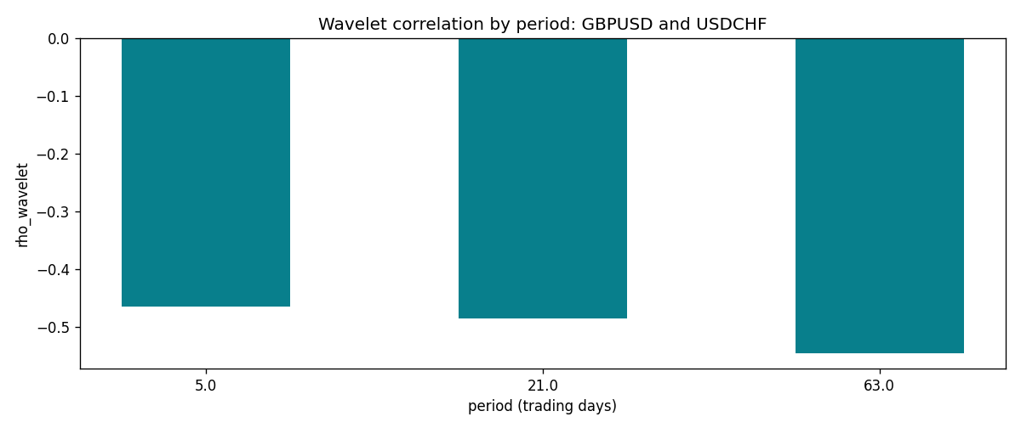

Data report
Matched rows and the scale sheet are in the sibling Excel workbook named GBPUSD-USDCHF_Wavelet_D1.xlsx. Embedding all rows as a Word table is impractical; this file holds column summaries and the first and last 15 matched rows.
Columns: time, GBPUSD_open, USDCHF_open, GBPUSD_high, USDCHF_high, GBPUSD_low, USDCHF_low, GBPUSD_close, USDCHF_close, GBPUSD_tick_volume, USDCHF_tick_volume, GBPUSD_spread, USDCHF_spread, GBPUSD_real_volume, USDCHF_real_volume, GBPUSD_log_return, USDCHF_log_return
Column summaries (matched calculation rows)
column | count | mean | std | min | 25% | 50% | 75% | max
GBPUSD_open | 7201 | 1.5160785 | 0.218271 | 1.06854 | 1.32499 | 1.51142 | 1.63167 | 2.1066
USDCHF_open | 7201 | 1.0982956 | 0.25264095 | 0.72022 | 0.92069 | 0.99019 | 1.2387 | 1.8219
GBPUSD_high | 7201 | 1.5223771 | 0.21884011 | 1.08366 | 1.32979 | 1.5182 | 1.6384 | 2.1161
USDCHF_high | 7201 | 1.1035944 | 0.25438893 | 0.73305 | 0.92495 | 0.99377 | 1.2436 | 1.8313
GBPUSD_low | 7201 | 1.5097512 | 0.21749696 | 1.03518 | 1.31949 | 1.50336 | 1.6244 | 2.0983
USDCHF_low | 7201 | 1.0931703 | 0.25105533 | 0.08565 | 0.91742 | 0.9867 | 1.2331 | 1.8121
GBPUSD_close | 7201 | 1.5161456 | 0.2182303 | 1.06879 | 1.3251 | 1.5114 | 1.63212 | 2.1065
USDCHF_close | 7201 | 1.0982864 | 0.25254184 | 0.72025 | 0.92098 | 0.9902 | 1.2387 | 1.8217
GBPUSD_tick_volume | 7201 | 94828.085 | 153546.21 | 62 | 10002 | 52900 | 91806 | 1273370
USDCHF_tick_volume | 7201 | 74189.26 | 113409.95 | 18 | 12770 | 40195 | 70240 | 858589
GBPUSD_spread | 7201 | 26.971115 | 19.193539 | 0 | 11 | 20 | 50 | 50
USDCHF_spread | 7201 | 26.114567 | 24.723753 | 0 | 5 | 16 | 50 | 100
GBPUSD_real_volume | 7201 | 3.5560898e+09 | 8.4438214e+10 | 0 | 0 | 0 | 0 | 2.4038164e+12
USDCHF_real_volume | 7201 | 2.3236557e+10 | 8.9041498e+10 | 0 | 0 | 0 | 0 | 1.9331921e+12
GBPUSD_log_return | 7201 | -2.316e-05 | 0.00564524 | -0.08388241 | -0.00312969 | 3.242e-05 | 0.00318104 | 0.03112653
USDCHF_log_return | 7201 | -7.148e-05 | 0.00659332 | -0.19545699 | -0.00335964 | 8.06e-05 | 0.00331782 | 0.09051364
First 15 matched rows (selected columns)
time | GBPUSD_log_return | USDCHF_log_return
1999-01-05 | -0.0028966287 | 0.0039424743
1999-01-06 | -0.00060452184 | 0.013605652
1999-01-07 | -0.002118709 | -0.0093883841
1999-01-08 | -0.0058954193 | 0.011040268
1999-01-11 | -0.0056851331 | 0.0052963193
1999-01-12 | 0.0022657001 | -0.0098275602
1999-01-13 | 0.0091330396 | -0.018259701
1999-01-14 | 0.0019376331 | -0.0024256692
1999-01-15 | -0.0017558204 | 0.01794228
1999-01-18 | 0.0012112405 | -0.0031856384
1999-01-19 | 0.0018745281 | -7.2518946e-05
1999-01-20 | -0.0049053846 | 0.0072259871
1999-01-21 | 0.0031518998 | -0.0038232689
1999-01-22 | 0.0024781662 | -0.0001445609
1999-01-25 | 0.0012066366 | 0.0024546976
Last 15 matched rows (selected columns)
time | GBPUSD_log_return | USDCHF_log_return
2026-10-13 | 0.0036434319 | -0.0024955621
2026-10-14 | -0.0049164679 | 0.0029388325
2026-10-15 | 0.0065976411 | -0.0097855323
2026-10-16 | 0.0037592051 | -0.0036230826
2026-10-19 | -0.0017500314 | 0.0036351779
2026-10-20 | 0.0055923442 | -0.0026281224
2026-10-21 | 0.0012476328 | -0.00040027413
2026-10-22 | 0.00022396082 | -0.0048036381
2026-10-23 | -0.0021146949 | 0.005652514
2026-10-26 | -0.0024340661 | 0.0018407959
2026-10-27 | -0.0023648393 | 0.0026100526
2026-10-28 | 0.0015771808 | -0.0010142111
2026-10-29 | 0.0035881935 | -0.0048680164
2026-10-30 | 0.0013450605 | 0.00071594559
2026-11-02 | 0.0010971256 | -0.0071459744

